**CN LAB 03**

**BASIL ALI KHAN**

**20K-0477**

**Task#01:**

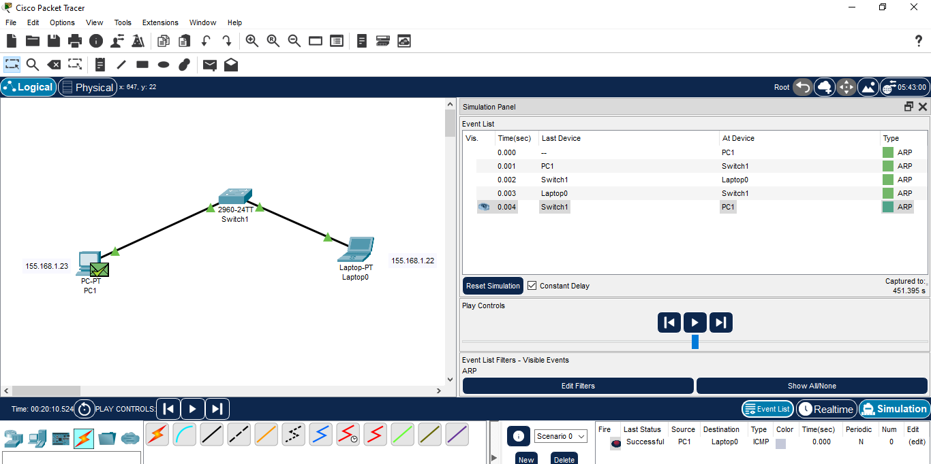

**Task#02:**

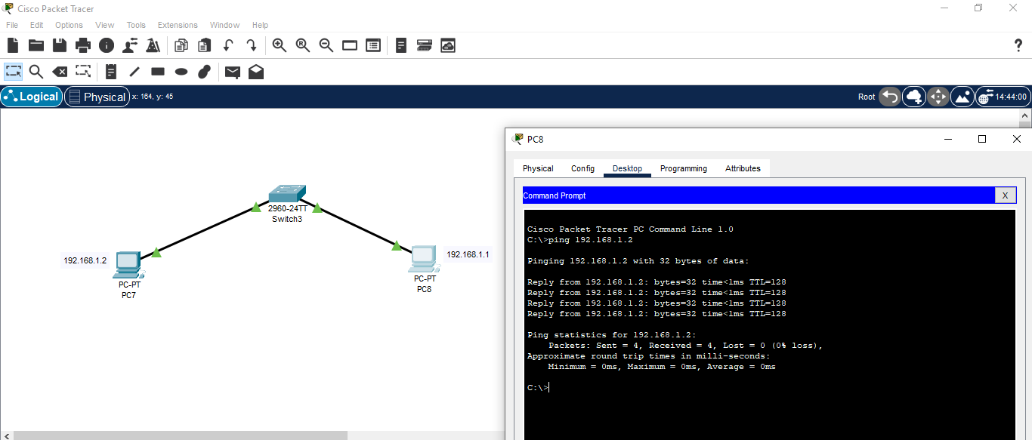

**Task#03:**

Used Crossover cable since both devices are similar.

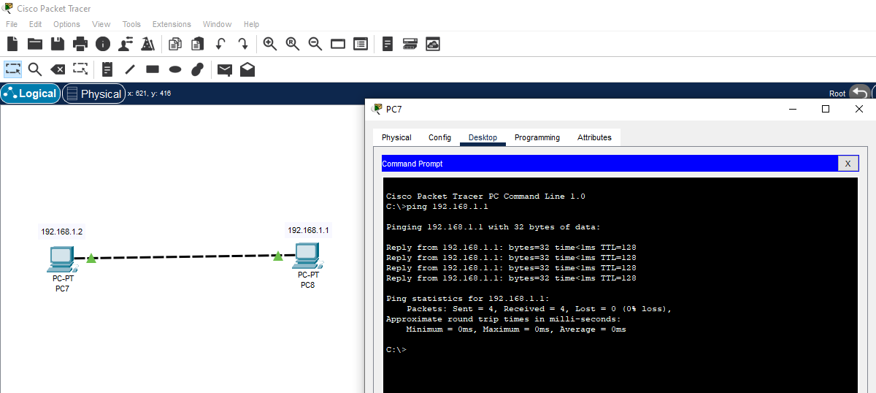

**Task#04:**

There are 5 command modes:  
1) Global configuration mode: apply features that affect the entire device.  
2) Interface Configuration mode: modify operation of interfaces  
3) Sub interface configuration mode: assigns IP and protocols to virtual  
interfaces formed from parent interface  
4) Router configuration mode: used to monitor and configure routers  
5) Line Configuration mode: modify operation of terminal line

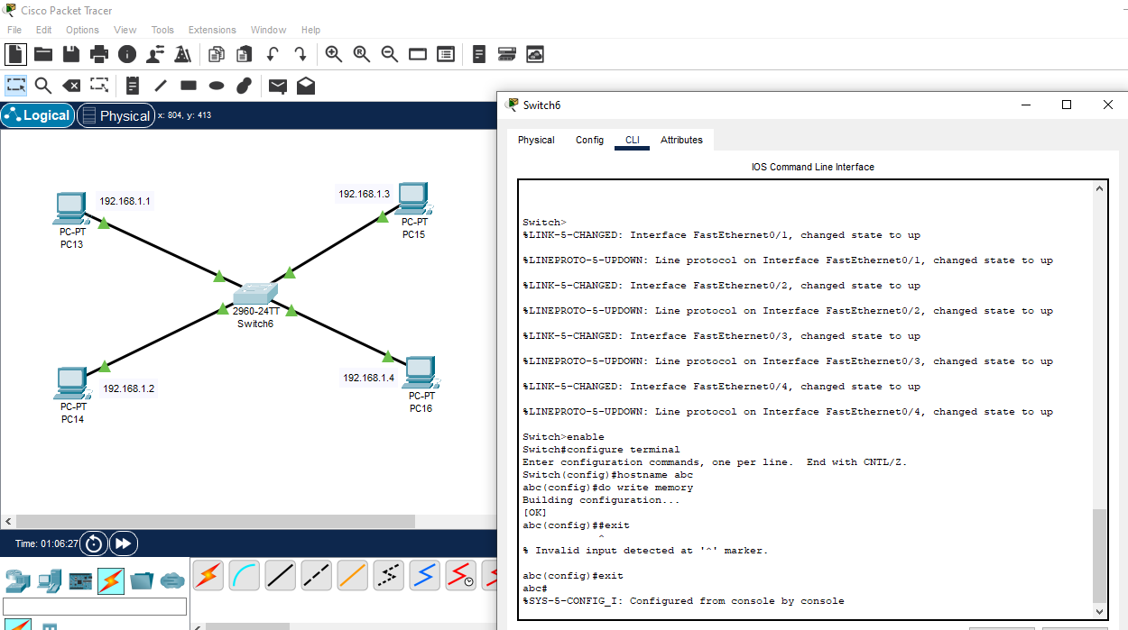

**Task#05:**

The function of the switch is to connect different devices together and allow them  
to communicate whereas the PCs and laptops are used by users to communicate  
and access data.

